

**HERITAGE INSTITUTE OF TECHNOLOGY**

Stream :Computer Science & Engineering

Paper : Software Tools Lab

Paper Code : CSEN 2152

Date of Examination : 27/07/2021

Full Signature of Student : Soumyadip Ghosh

|  |  |  |  |  |  |  |  |  |  |  |  |  |  |
| --- | --- | --- | --- | --- | --- | --- | --- | --- | --- | --- | --- | --- | --- |
| **Roll No.** | **1** | **2** | **6** | **1** | **9** | **0** | **0** | **1** | **1** | **5** | **8** |  |  |
| **Reg. No.** | **0** | **2** | **8** | **8** | **3** | **0** |  |  |  |  |  |  |  |
| **of** | **2019...........................… 2020........................................** | | | | | | | | | | | | |

|  |  |  |  |  |  |
| --- | --- | --- | --- | --- | --- |
| **Q. No.** | **Marks** | |  | **Q. No.** | **Marks** |
| **1.** |  | | **7.** |  |
| **2.** |  | | **8.** |  |
| **3.** |  | | **9.** |  |
| **4.** |  | | **10.** |  |
| **5.** |  | | **11.** |  |
| **6.** |  | | **12.** |  |
| **Total Marks** | |  | | | |
| **Total in Words** | |  | | | |
| **Signature** | |  | | | |

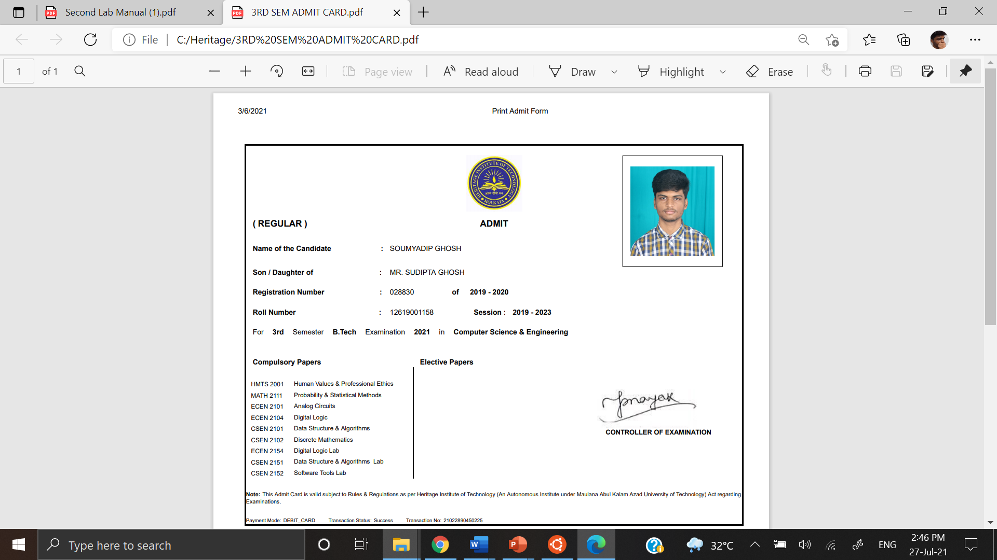

Problem Statement:

**12. Run the following program and see the type of memcheck error using valgrind. Explain the errors.**

#include <stdlib.h>

#include <stdint.h>

int main() {

char* alphabet = calloc(26, sizeof(char));

for(uint8_t i = 0; i < 26; i++) {

*(alphabet + i) = 'A' + i;

}

*(alphabet + 26) = '\0';

free(alphabet);

return 0;

}

Procedure followed:

* Compiling the program:

gcc -g p1.c -o p1

* Using Valgrind:

valgrind –tool=memcheck ./p1

Output Screen:

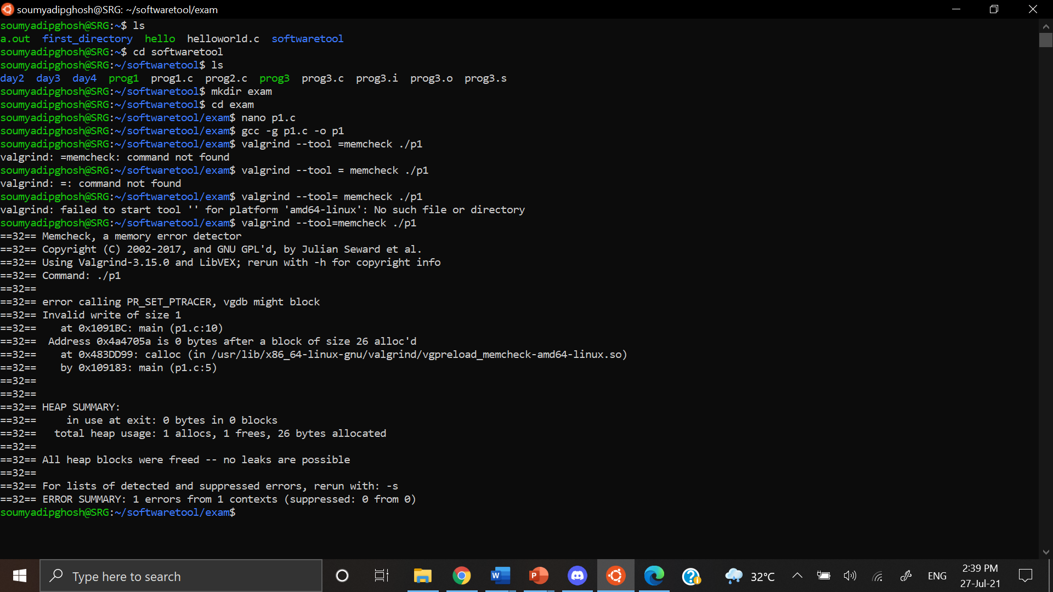

Error faced:

Here using valgrind we can see that there is an ‘Invalid write of size 1’ in line number 10. It says further that

The address is 0 bytes after a block of size 26 that was allocated. Now inspecting line number 10 we can see that we are assigning a null character in 26th index of the string. However, in line number 5, we have only allocated the size of string as 26 using calloc. Hence when we try to assign something in 26th index, we are trying to assign something beyond memory bounds.

Error correction:

We can correct the problem by assigning the space of 27 in calloc instead of 26.

Corrected code:

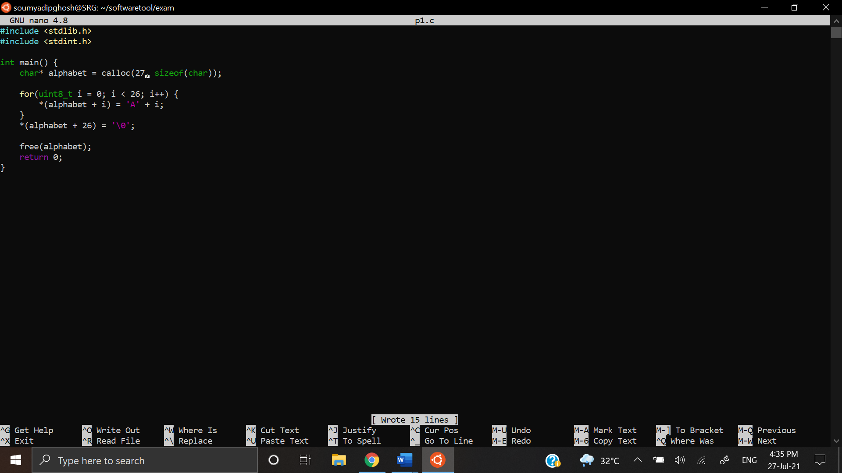

Output screen after correction:

